Parish of Ellesborough
Housing Needs Report

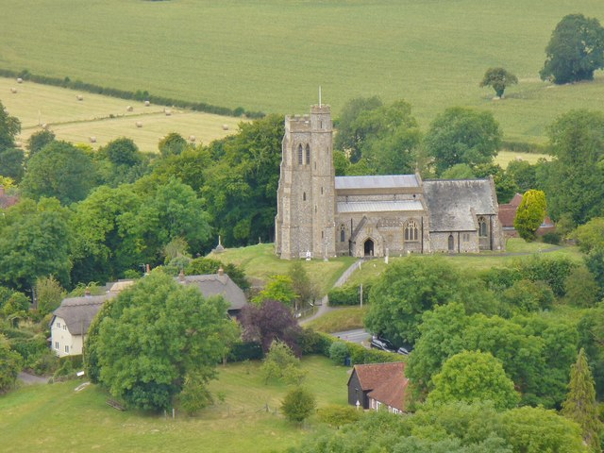

Produced by: Devon Communities Together

On behalf of: Ellesborough Parish Council

Date October 2017

Contents

- Executive Summary

- Aims of the Survey

- Survey History, Methodology and Response

- Introduction and Information about Ellesborough

- General Survey Findings

- Housing Aspirations of Older People

- Assessment of those wishing to move home within next 5 years

- Assessment of those in need of affordable housing

- Conclusions – Future Housing Need for Ellesborough

Please note that this document is the intellectual property of the Devon Rural Housing Partnership. If this document is used by any organisation to support a development (other than the commissioning organisations) then a fee will be charged. Details of this fee can be obtained from the Rural Housing Enabler at Devon Communities Together.

Devon Communities Together
First Floor, 3 & 4 Cranmere Court
Lustleigh Close
Matford Business Park,
Exeter. EX2 8PW
Tel 01392 248919

www.devoncommunities.org.uk

1 Executive Summary

Principal Conclusions

The survey identified a need for 9 affordable homes and 4 open market homes within the next 5 years.

Key findings

Affordability

- The survey found 9 households in housing need who could not afford to buy or rent in the open market.

Tenure

- 5 of the households in need qualified for affordable rent, 4 may be able to afford a shared ownership property.

Size of Property Required

- 8 x 1 or 2 bedroom properties for singles/couples
- 1 x 3 bedroom property for a family

Other Findings

- 361 surveys were delivered and 102 survey forms were returned. The response rate was 28%.

  - 73% of those who answered the question said they would be in favour of a small development of affordable housing for local people. 13 households did not answer this question.

  - 14 households expressed an interest in joining a CLT. 9 left contact details.

  - A need for 4 open market homes in the parish was identified.

2. Aims of the Survey

- To investigate the housing need, tenure and size of homes required for local people living or working in the parish and those wishing to return.
- To establish the general level of support for new homes in the parish, with an emphasis on homes for local people with housing needs.
- To establish the views of the whole community on future housing in the parish.
- To assist the Parish Council and District Council with future planning for the parish.

3. Survey history, methodology and response

3.1 History
Ellesborough Parish Council decided to carry out a survey to assess future local housing need. The Rural Housing Enabler for Community Impact Bucks attended a Parish Council meeting on 21st March 2017 and it was agreed to proceed with the survey. As Community Impact Bucks does not have the resources to conduct a housing need survey, Devon Communities Together (DCT) was approached to carry out the survey on their behalf. DCT is an independent, non-profit making organisation that carries out a similar role in Devon. DCT received assistance from Community Impact Bucks and Wycombe District Council with background data for the survey. Survey forms were finalised and 350 forms were hand delivered to every household in Ellesborough parish with the exception of Dunsmore. Parishioners were able to return the survey in a reply paid envelope. The deadline for the return of the survey was 30th September 2017. As the hamlet of Dunsmore was not included in the original survey, additional forms were hand delivered to 11 homes in this settlement on 16th/17th October with a closing date of 31st October to ensure that every household in the parish had a chance to take part in the survey.

3.2 Methodology
The survey was carried out using a standard methodology approved by local planners. Background notes on the methodology can be obtained from the Rural Housing Enabler.

The survey form was in 3 parts. The first section asked a limited number of questions about the type of household and their support for affordable housing. All residents were invited to respond to this part of the survey. The second section was aimed at parishioners aged over 55 to gauge the specific needs of older residents. The third part of the survey was designed to be completed by households who intend to move home within the next 5 years and wish to remain living in the parish. Both those who have an affordable housing need and those who wish to buy on the open market were invited to complete this section of the form. A reminder was also sent to those on the Bucks Home Choice register who did not complete a survey form.

3.3 Response
- 102 surveys were returned, which is a response rate of 28% of all dwellings surveyed.

- The survey achieved its aim of identifying actual households in need. Out of the 102 returned surveys, 13 were returned with Part 3 completed.

It should be noted that whilst apparent inconsistencies in responses are followed up, the information given is taken at face value.

4. Introduction and Information about Ellesborough

4.1 Overview of Ellesborough
Ellesborough is a rural parish located in the Wycombe District of Buckinghamshire. It lies at the foot of the Chiltern Hills and at the edge of the Chilterns AONB, 2 miles from Wendover and 5 miles from Aylesbury. The parish consists of the villages of Ellesborough and Butlers Cross as well as the smaller hamlets of Terrick and Dunsmore. The Prime Minister’s country residence, Chequers, is located nearby as is the world-renowned Stoke Mandeville hospital.

The area is popular with walkers and cyclists and has a number of footpaths and bridleways, including the Ridgeway national path, running through it.

Local amenities include a village church, village hall (at Butlers Cross), public house (at Butlers Cross), golf club, brewery and farm shop. Dunsmore has its own chapel and village hall. There is a primary school in the neighbouring parish of Great Kimble.

The parish is vibrant and active with several local groups and societies including a silver band.

Transport links to Ellesborough are good with 2 train stations located at the neighbouring village of Little Kimble and the larger town of Wendover with regular trains to London and Aylesbury. There are also regular daily bus services (weekdays only) to High Wycombe, Aylesbury and smaller towns and villages along the route.

4.2 Population Figures
In the 2011 census the usually resident population of Ellesborough was recorded as 820 in 347 households.

4.3 Council Tax Bandings
A breakdown of Council Tax bandings in Table 1 (from 2011 Census) shows that there are only 38 properties (11% of all dwellings) in the lower three bandings out of a total of 354. These represent the entry level properties that people on lower incomes would be able to afford. This is a very low percentage and indicates that there is very little availability of smaller, cheaper properties for purchase and rent within the parish.

Table 1
Band A | Band B | Band C | Band D | Band E | Band F | Band G | Band H | Total
8 | 17 | 13 | 67 | 35 | 68 | 128 | 18 | 354

4.4 Property Prices and Rent
In the last 2 years the Land Registry has recorded 30 property sales in the parish. The average price of properties whose value was shown was £653,180. Prices ranged from £264,000 for a 2 bedroom house to £1,800,000 for a 5 bedroom house.

There are currently 16 property listings on the Rightmove website in the parish. The cheapest house on the market at the moment is a 3 bedroom property for £325,000. There are only 2 houses for sale under £400,000.

To assess whether a household can afford to buy in the open market it is necessary to look at the cost of an entry level property in the local market. This is done by comparing information on recent house sales and homes currently on the open market. Average rents are identified by comparing local private rents gained from the housing need survey with rents of properties currently on the market. From this information, we can establish typical rents to assess affordability. There were no one bedroom properties for rent on the open market at the time of writing this report therefore data has been taken from surrounding rural areas.

The figures used to assess affordability are set out in Table 2 below.

Table 2
Size | Property price | Weekly rent
1 bedroom | £180,000 | £165
2 bedroom | £300,000 | £250
3 bedroom | £400,000 | £300

5. General Survey Findings

5.1 In favour of a small local development
Respondents were asked if they would be in favour of a small number of homes for local people being built if the need for affordable housing were proven. 73% of those answering the question said they would be in favour. 27% said they were against any development. It should be noted that 13 households did not respond to this question. Fig.1 below shows the breakdown.

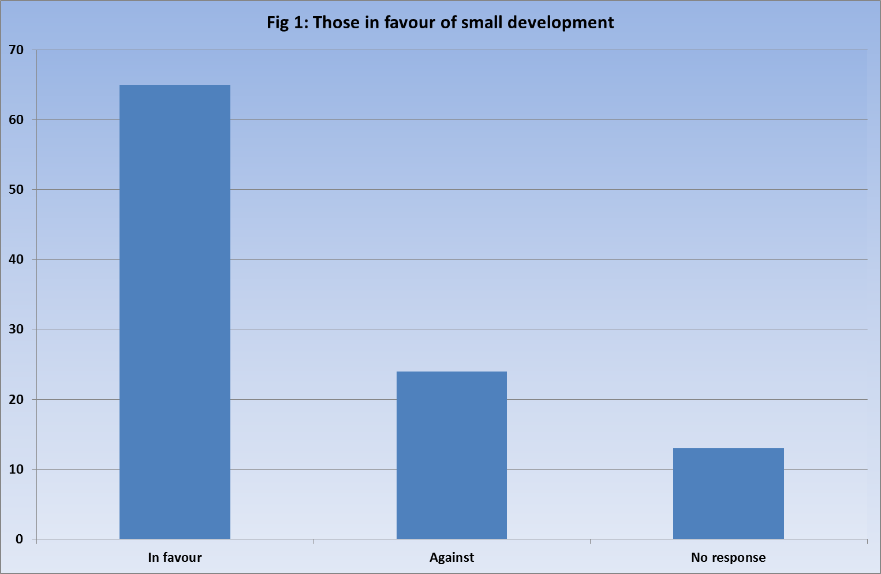

5.2 Suggestions where a development could be sited and general comments
26 individuals made suggestions for sites or more general comments about affordable housing. The vast majority cited Chalkshire Road as the most suitable location for new development. The full list will be made available to the Parish Council on a separate document.

5.3 Knowledge of those who have left parish in last 5 years
Respondents were asked if they knew of anybody who had had to leave the parish in the last 5 years due to lack of suitable housing.

- 13 households replied that they did know of someone

5.4 Current tenure
Of the 101 respondents who provided details, 86 (85%) own their own home, 4 (4%) rent from a private landlord, 5 (5%) rent from a housing association, 4 (4%) live with relatives and 2 (2%) live in tied housing. This is shown in Figure 2 below.

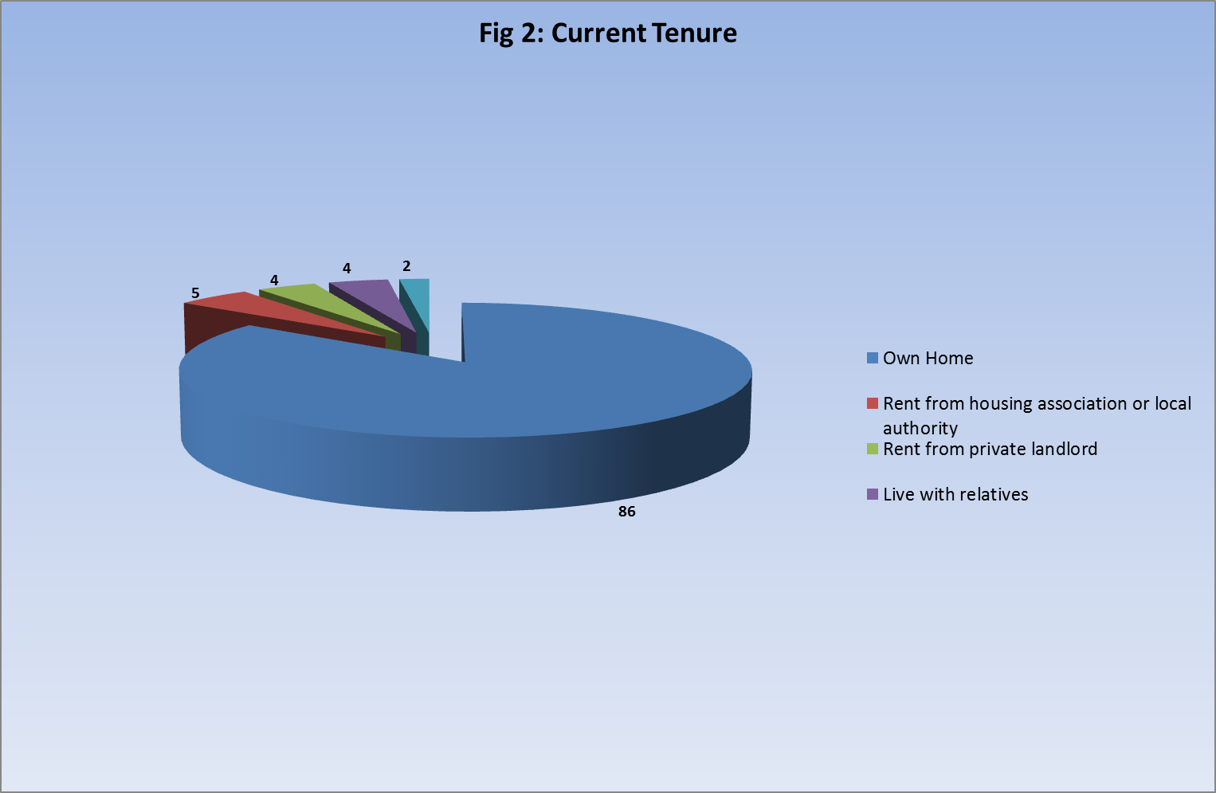

5.5 Main or second home
None of the responders were second home owners.

5.6 Parish of Residence
Respondents were asked which parish they lived in.

- 94 lived within Ellesborough parish.
- 3 lived in Little Kimble.
- 1 lived in North Lee
- 1 lived in Aylesbury
- 1 lived in Wendover

5.7 Number of bedrooms in current home
Respondents were asked how many bedrooms their current home has. The replies are shown in Table 3 below.

Table 3
Number of bedrooms | 1 | 2 | 3 | 4+
Respondents | 3 | 12 | 26 | 60

The majority of those responding to the survey live in large properties with 4 or more bedrooms.

5.8 Community Land Trusts (CLTs)
Respondents were asked whether they would consider becoming a member of a CLT.

- 14 households expressed an interest and 9 of these left contact details.

- Housing needs and aspirations of older residents

Part 2 of the questionnaire was directed at residents over the age of 55. The number of people over the age of 55 is set to rise significantly across the UK over the next 20 years. In 2014 the Office for National Statistics published population projections for the next 20 years. These figures show that between 2017 and 2034 the percentage of people over the age of 55 will have increased by 40% across Buckinghamshire and by 32% in Wycombe during that period.

128 people answered Part 2 of the survey from 77 households with at least one member over the age of 55. This is 75% of the total number of households responding.

6.1 Age of Respondents to Part 2 survey
Respondents were asked to give their age in 10 year bands. As can be seen in Table 4 below, the majority of those who replied (82%) were aged between 55 and 75.

Table 4
Age Group | 55-65 | 66-75 | 76–85 | Over 85
Number | 56 | 49 | 21 | 2

6.2 Future Housing Plans
Households were asked about their future housing plans.

- 12 households plan to move within the next five years. Of these, 3 would like to remain in Ellesborough.
- 1 of these 3 households may need affordable housing.
- 13 further households expect to move after five years.
- 51 have no plans to move at the moment.
- 1 household did not answer the question.

6.3 Reasons for moving home in next 5 years
Households were asked to list the reasons they may wish to move home in the next 5 years.
They could give more than one reason. The reasons are listed below in Table 5.

Table 5
Reason for Moving | Number
Need to downsize to a smaller more manageable home | 19
Cheaper running costs | 11
Proximity to shops/amenities | 10
Proximity to public transport | 9
One level for medical reasons | 8
To be near family/carers | 8

The largest single reason given for wanting/needing to move was the need for a smaller property as respondents cannot manage their current home.

6.4 Type of Accommodation preferred by older persons
Older households were asked what type of accommodation they may need in the future. The majority preferred a home better suited to their needs but not designed for older people. Preferences are shown in Table 6 below.

Table 6
Type of Accommodation Preferred by Older Persons | Number
Home better suited to needs but not specifically designed for older people | 28
Home specially designed for older people | 3
Residential / nursing home | 1

6.5 Conclusion – Older Persons Needs
The older persons’ survey shows that the majority of households (67%) have no plans to move home. However, the parish does have a small number of older households who wish to downsize to smaller accommodation that is easier to maintain, has lower running costs and is closer to amenities and support.

Only 1 of the households that expect to move home within the next 5 years and remain in Ellesborough may need affordable housing. The remaining 2 households would require open market housing. Small open market bungalows, flats and houses can be built, however, developers who build open market homes do not usually attach any kind of local connection covenant to them as this reduces the value of the homes. This means that any open market properties cannot be guaranteed for local people. Meeting the housing needs of this group of people should be given further consideration.

- Assessment of those wishing to move to a new home in
Ellesborough within the next 5 years

Part 3 of the survey was aimed at those who expect to need to move home within the next 5 years and remain in Ellesborough. It asked questions regarding size and make-up of the new household, local connection and financial circumstances. This information helps to identify the number of households that are eligible for both open market and affordable housing in the parish and the size, tenure and type of homes required.
13 households indicated a need to move within the next 5 years and to remain in Ellesborough.
7.1 Minimum bedroom requirement
Respondents were asked the minimum number of bedrooms they would require in their new home. Table 7 below shows the breakdown. It should be noted that there are criteria relating to affordable housing that set the number of bedrooms that a household are eligible for based on the number of adults and children in that household.

Table 7
1 bedroom | 2 bedroom | 3 bedroom | 4 bedroom
4 | 5 | 3 | 1

7.2 Timescales for moving
Households completing this part of the form were asked to identify when they would need to move. They could give more than one reason.

- 3 households indicated a current need to move.
- 4 households indicated a need to move within the next 1-3 years.
- 6 households indicated a need to move within the next 5 years.

7.3 Housing tenure
Respondents were asked what type of accommodation they would consider moving to. The results are shown in table 7 below. Respondents could choose more than one option.

Table 7
Shared ownership/equity | Affordable/Social rent | Self-build | Discounted market | Starter home | Open market | Rent to buy | Open market
5 | 4 | 3 | 4 | 5 | 1 | 2 | 5

7.4 Reasons for moving
Respondents were asked why they wished to move home. They could tick more than one box.

Table 9
Reason for wishing to move | No of respondents
Need to downsize to a home with fewer bedrooms | 4
Sharing facilities with someone who is not going to be moving with you | 3
Need to move for health/mobility reasons | 2
Struggling to afford current home | 1
Will be leaving home and do not expect to be able to rent or buy privately | 5
Wish to move back to the parish and have a strong local connection | 4
Need to move for work | 1
Other (wish to purchase first home) | 1

7.5 Budget for new home
Respondents who wished to purchase a home were asked about their budget. Table 10 below shows the breakdown of replies.

Table 10
£150,000 - £200,000 | £200,000 - £250,000 | £250,000 - £300,000 | £300,000 - £350,000 | £350,000 +
4 | 2 | 1 | 1 | 3

8. Assessment of those in affordable housing need
This section of the survey looks at the number of households who would qualify for an affordable home in the parish, based on their household income and savings.

8.1 Exclusions
All 13 of the households who expressed a need to move within the next 5 years and remain in Ellesborough were assessed. 4 of these were excluded from the assessment at this stage because they already own their own home and have the finances to continue with home ownership.

This leaves 9 households who may qualify for affordable housing.

8.2 Local Connection
In order to qualify for affordable housing, respondents must have a local connection to Ellesborough. This is set by Wycombe District Council and the criteria are as follows:-

- A member of the household has lived in the parish for the last 5 years.
- A member of the household works in the parish.
- A member of the household has immediate family (father/mother) who has lived in the parish for the last 5 years.

All 9 of the respondents have this connection.

8.3 Housing Options
The housing options available to the 9 households in need are now given consideration. Respondents provided information on income and savings which allows an assessment of what the household can afford to pay for their accommodation. These incomes are shown in Figure 3 overleaf.
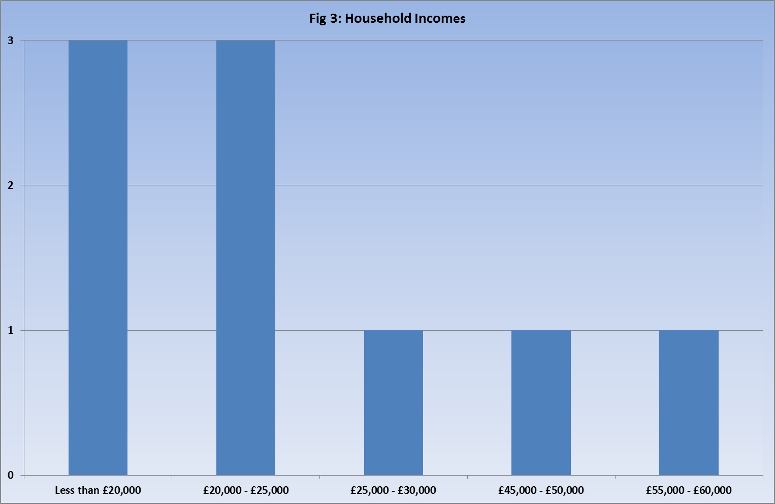

Given the financial circumstances of the households in need, 3 may be able to afford a shared ownership home but the other 6 would require affordable rented housing.

The survey also asked households who had a housing need which type of housing they were interested in. Respondents could give more than one option. The responses are listed in Table 11 below.

Table 11
Type of housing | Interested
Shared ownership/equity | 5
Affordable rented | 4
Self-build | 2
Discounted market sale | 4
Starter home | 5
Rent to buy | 1

8.4 Other evidence of housing need
As well as data collected by this survey other evidence of housing need should be considered. The housing waiting list or register for Buckinghamshire is called Bucks Home Choice. Applicants are given a banding from A to D depending on their level of need. There are no households living in Ellesborough currently registered on Bucks Home Choice.

8.5 Housing Mix
The suggested mix of housing is shown in Table 12 below. This takes account of the family makeup as declared on the survey form and the type of housing required.

Table 12
Type of Property | Affordable Rent | Shared Ownership | Totals
1 or 2 bedroom property for single people | 5 | 1 | 6
1 or 2 bedroom property for couples | 1 | 1 | 2
2 bedroom property for families | 0 | 0 | 0
3 bedroom property for families | 0 | 1 | 1
Totals | 6 | 3 | 9

9. Conclusion - Future Housing Need for Ellesborough

Overall, it must be remembered that this Housing Needs Survey represents a snapshot in time. Personal circumstances are constantly evolving. Any provision of affordable housing would, by necessity, need to take account of this. However, given the level of response to the survey, and in spite of the potential for circumstances to change, the Parish Council can feel confident in the results of this survey. The survey has identified a need in the near future for 9 units of affordable housing and 4 units of open market housing.

As the needs of households constantly evolve, the level and mix of need in this report should be taken as a guide. In particular, it may be appropriate to vary the mix of sizes provided. This report remains appropriate evidence of need for up to five years.

Recommendation

It is recommended that the Parish Council:

- Note this report.
- Consider the options for addressing the need for 9 affordable homes.

Property data correct as of 2/10/17

